Zbigniew Łapiński
He heads the management board of ESPPOL Trade S.A. and is a member of the management board of Anwim S.A and Anwim S.A's director of purchasing, logistics and key customers.
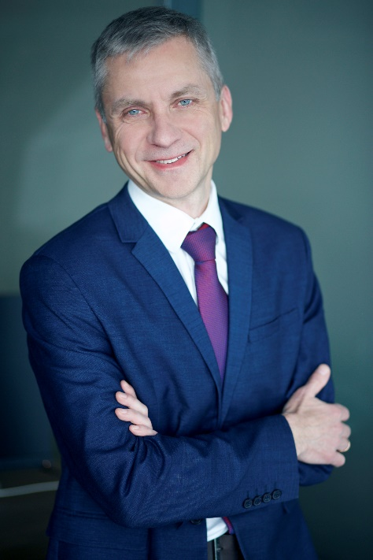
Zbigniew Łapiński is responsible for Anwim S.A's fuel purchasing, fuel transport and fuel logistics, as well as for sales to Anwim's key customers. He has been working in the fuel industry since 1996. He joined Anwim S.A in 2000 and has been a member of its management board continuously since 2002. Since 2020, he has been the head of the management board of ESPPOL Trade S.A., an international trading business, operating as an importer of fuels and liquid biofuels.

Areas of expertise (suggested areas for interviews)
- industry commentaries: Poland's fuel sector,
- the challenges for the fuel sector in Poland and Europe,
- fuel market regulations,
- fuel import operations for the MOYA brand,
- a development strategy for ESPPOL Trade S.A.

